AZURE BLOB STORAGE -------> DATA BRICKS ------> AZURE SQL SERVER

SERVICES REQUIRED :

1. BLOB STORAGE
2. DATA BRICKS
3. AZURE SQL SERVER

BLOB

BLOB

ADLS

A.SQL

A.SQL

ADLS

AZURE DATA BRICKS

AS U KNOW CREATE THE STORAGE ACCOUNT FIRST AND SQL ACCOUNT IN AZURE

LEST SEE HOW CREATE ACCOUNT IN DATABRICKS

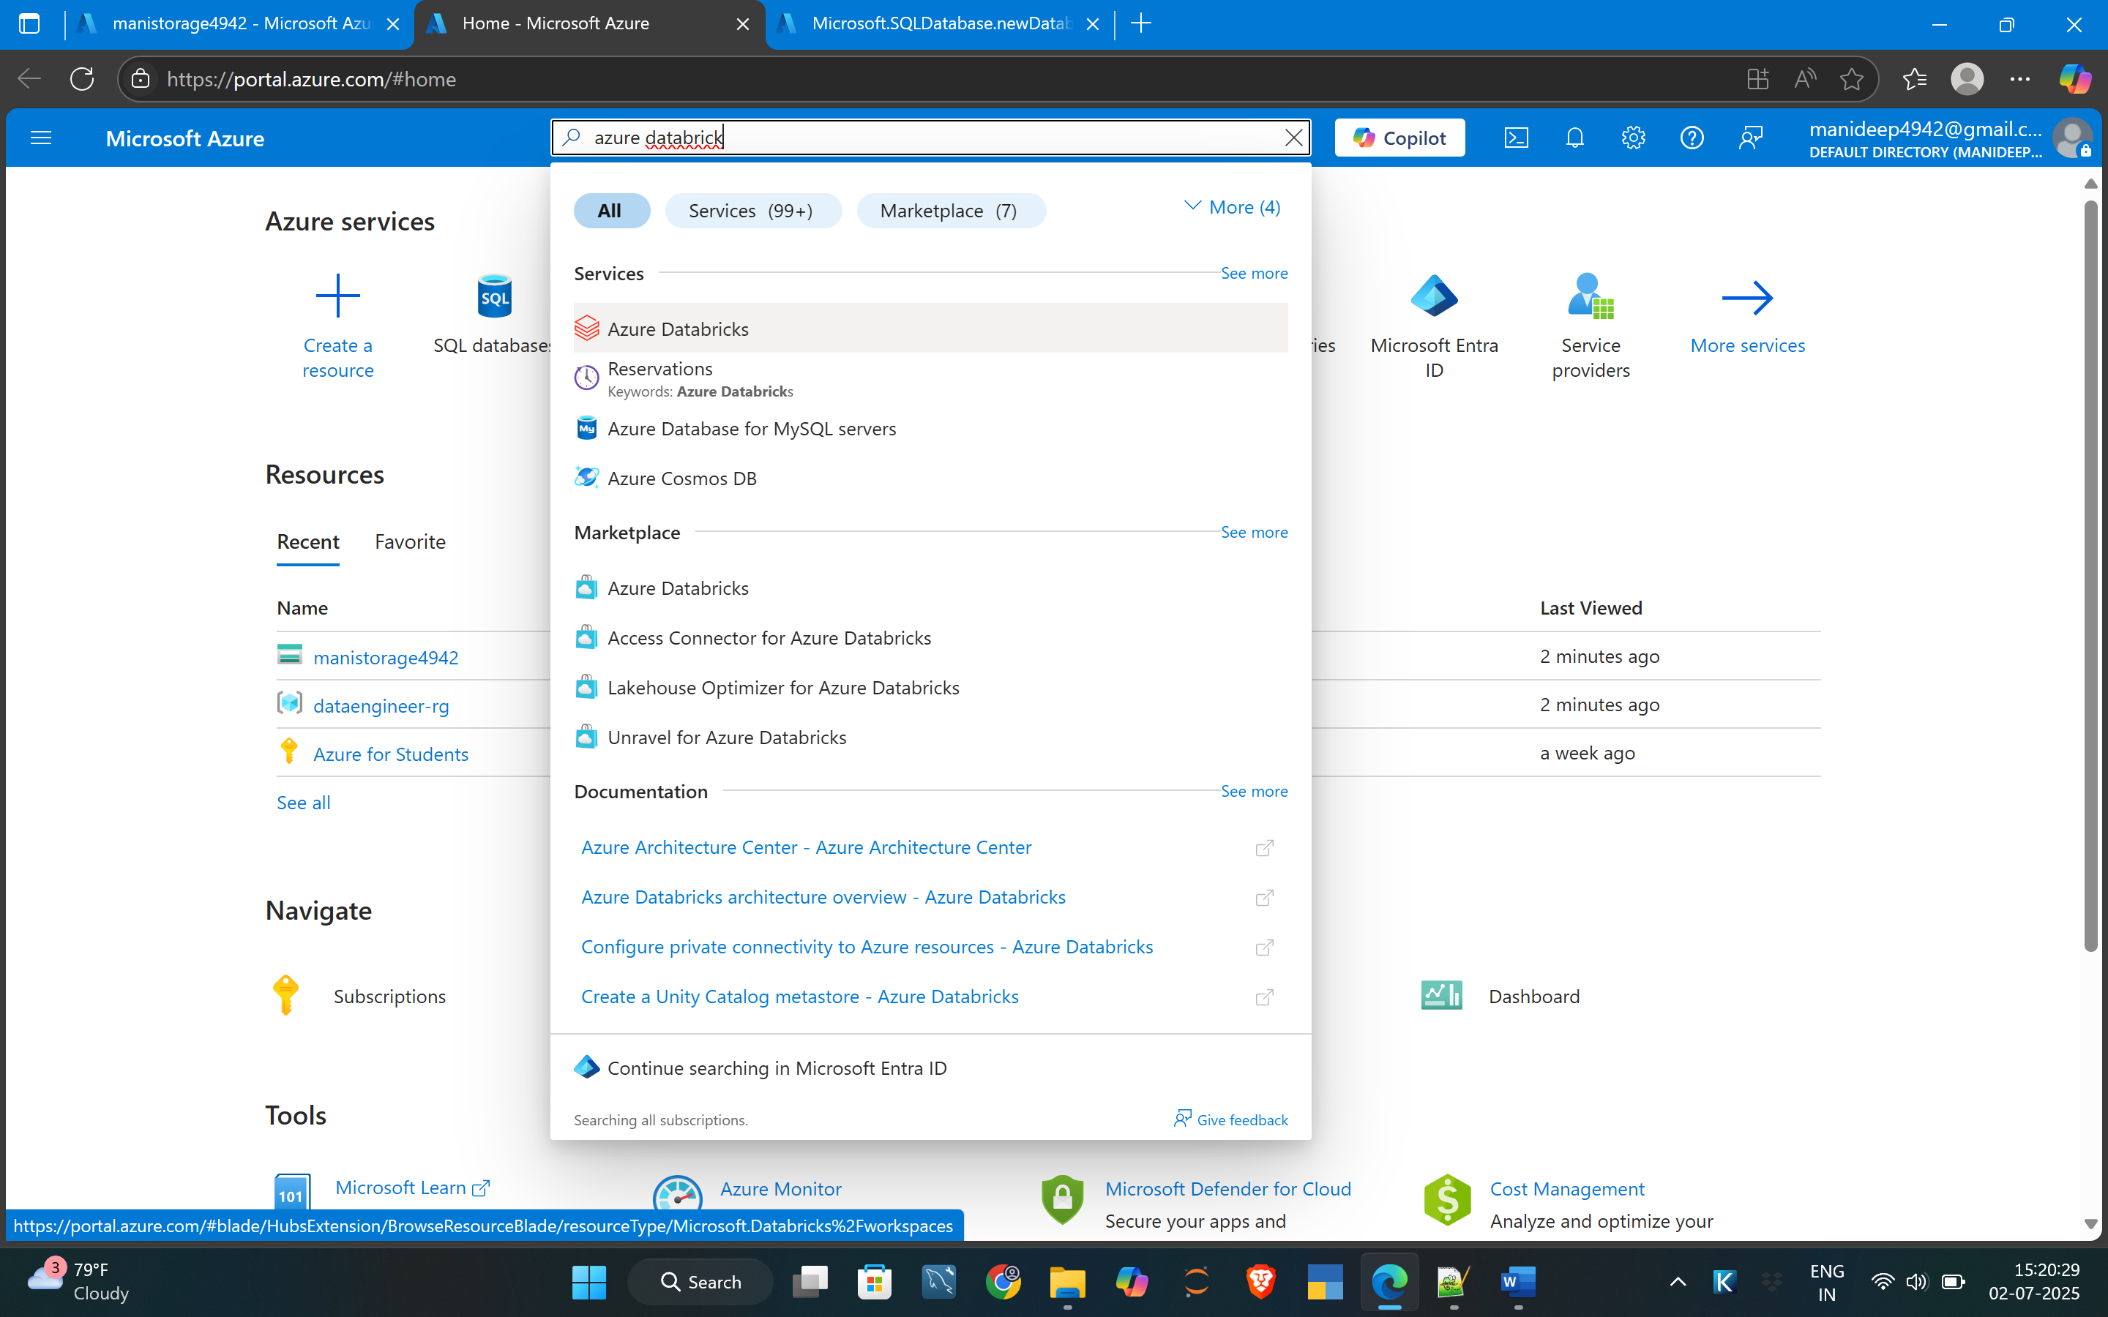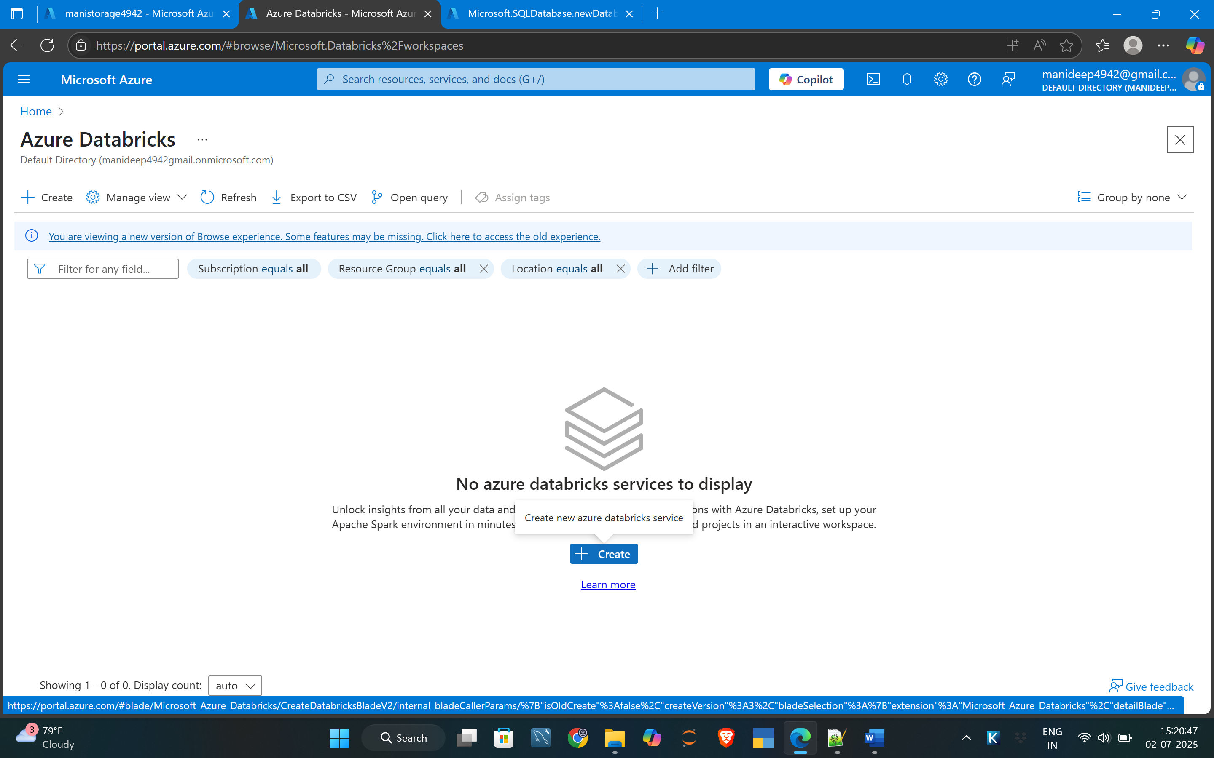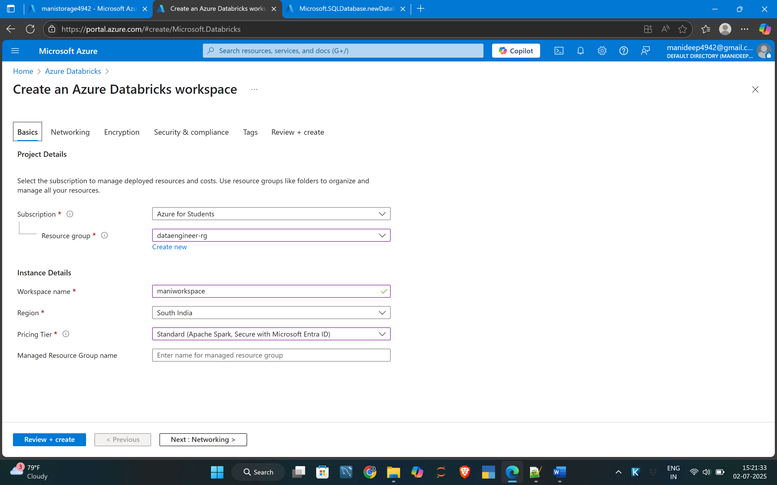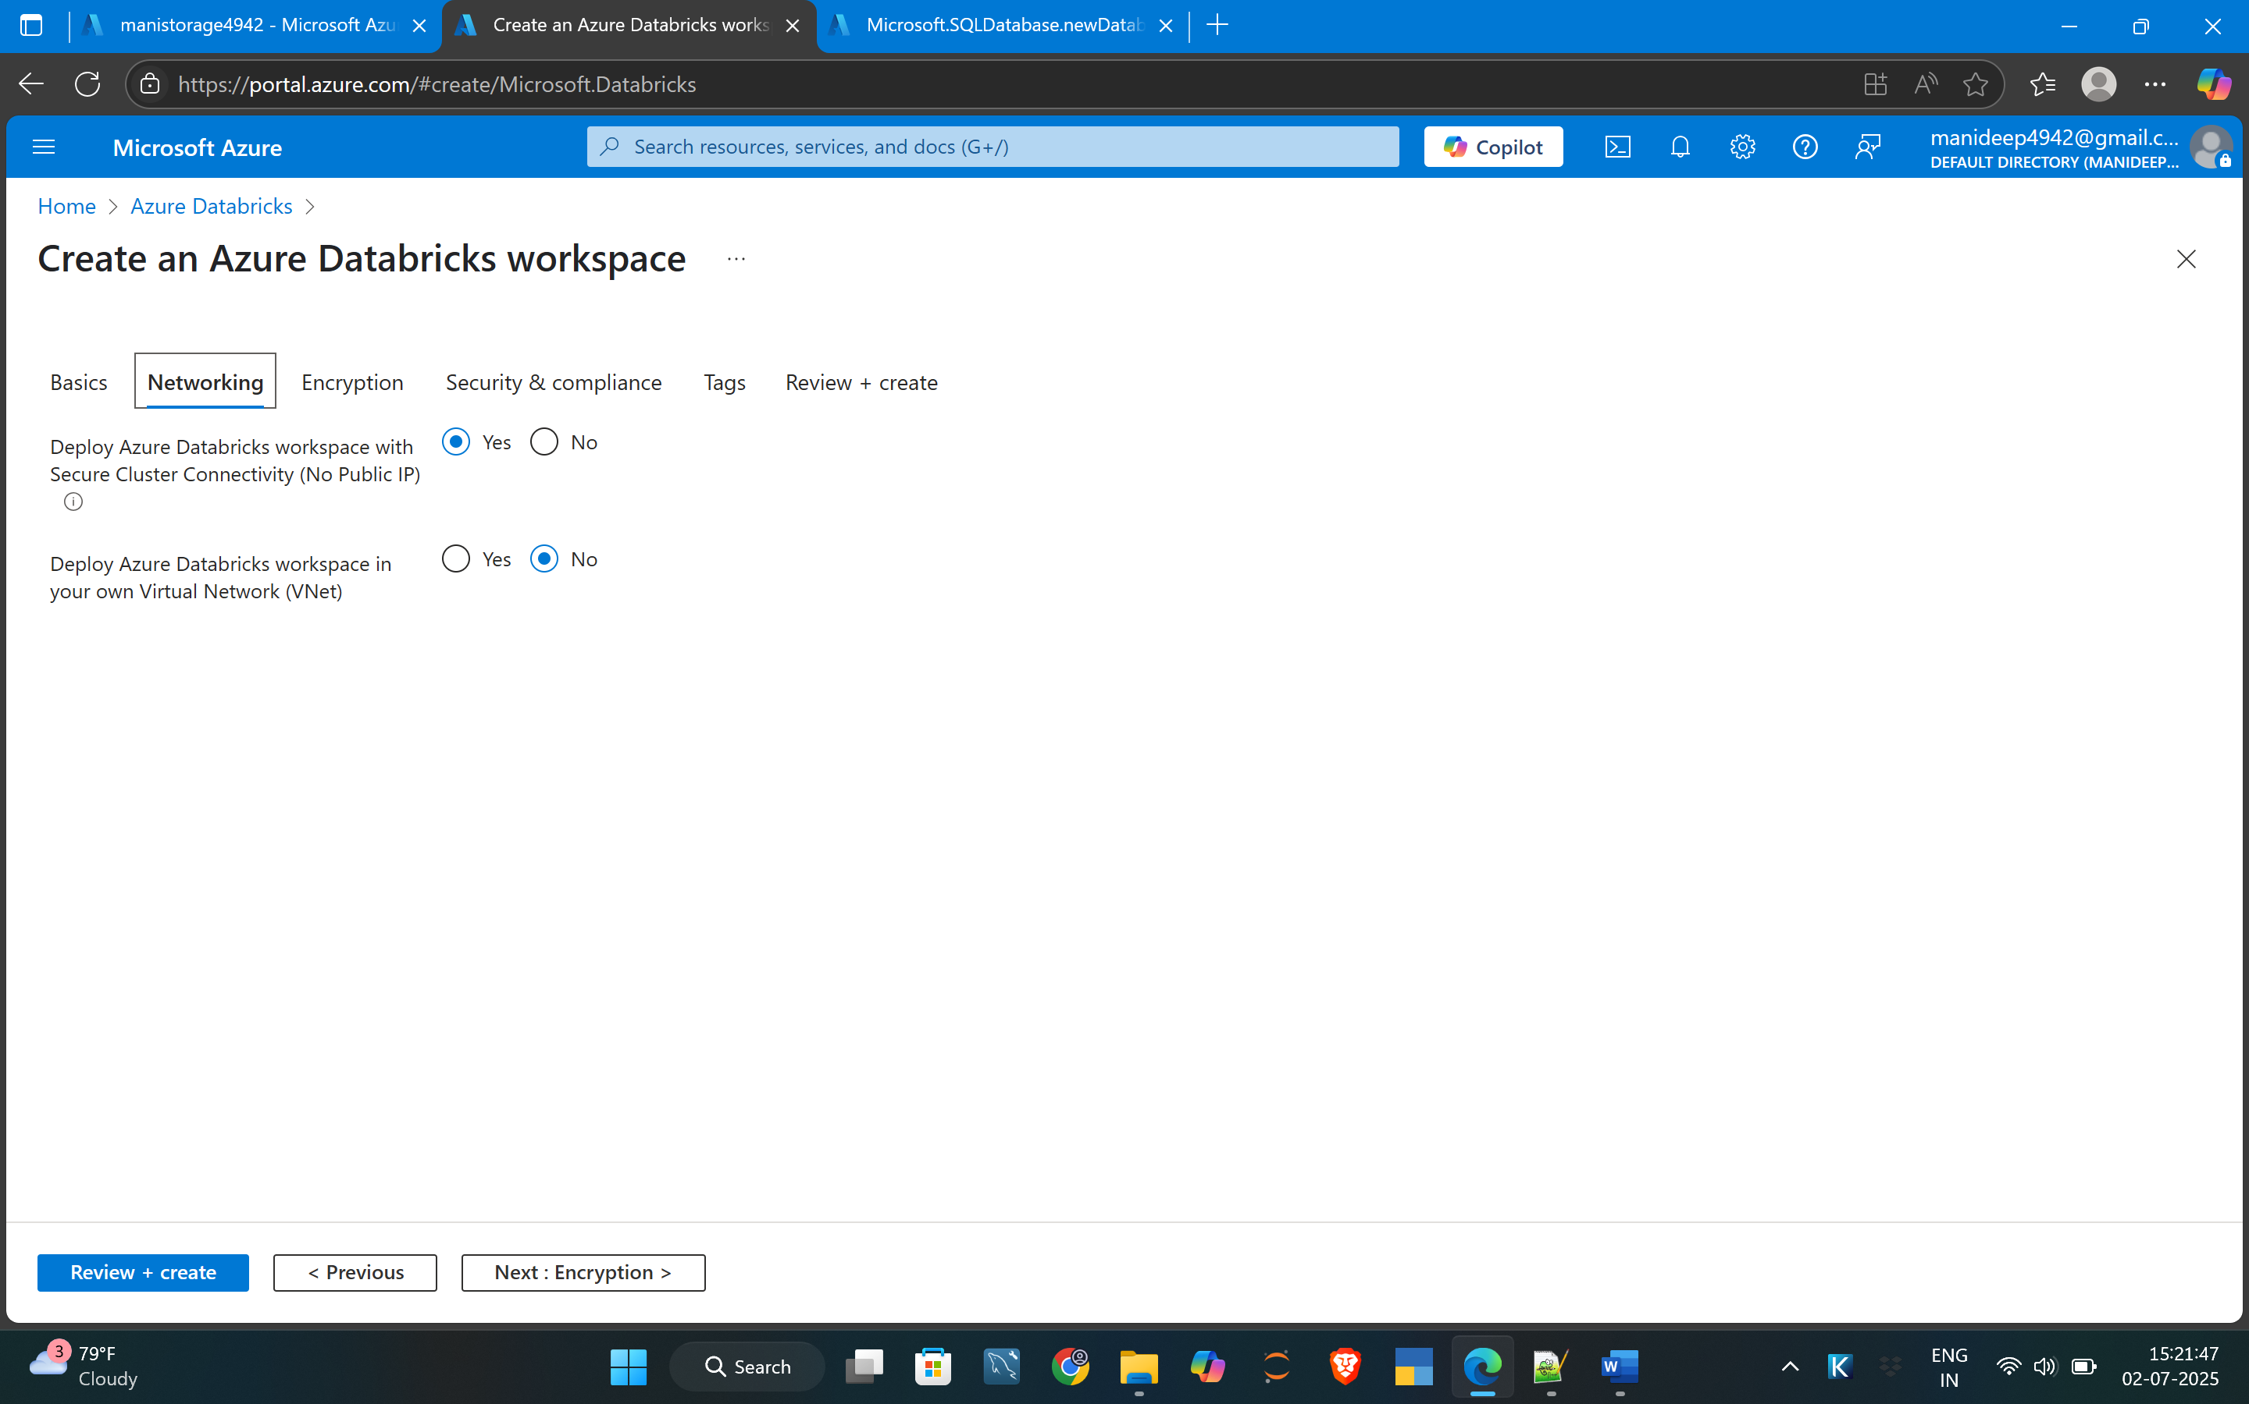

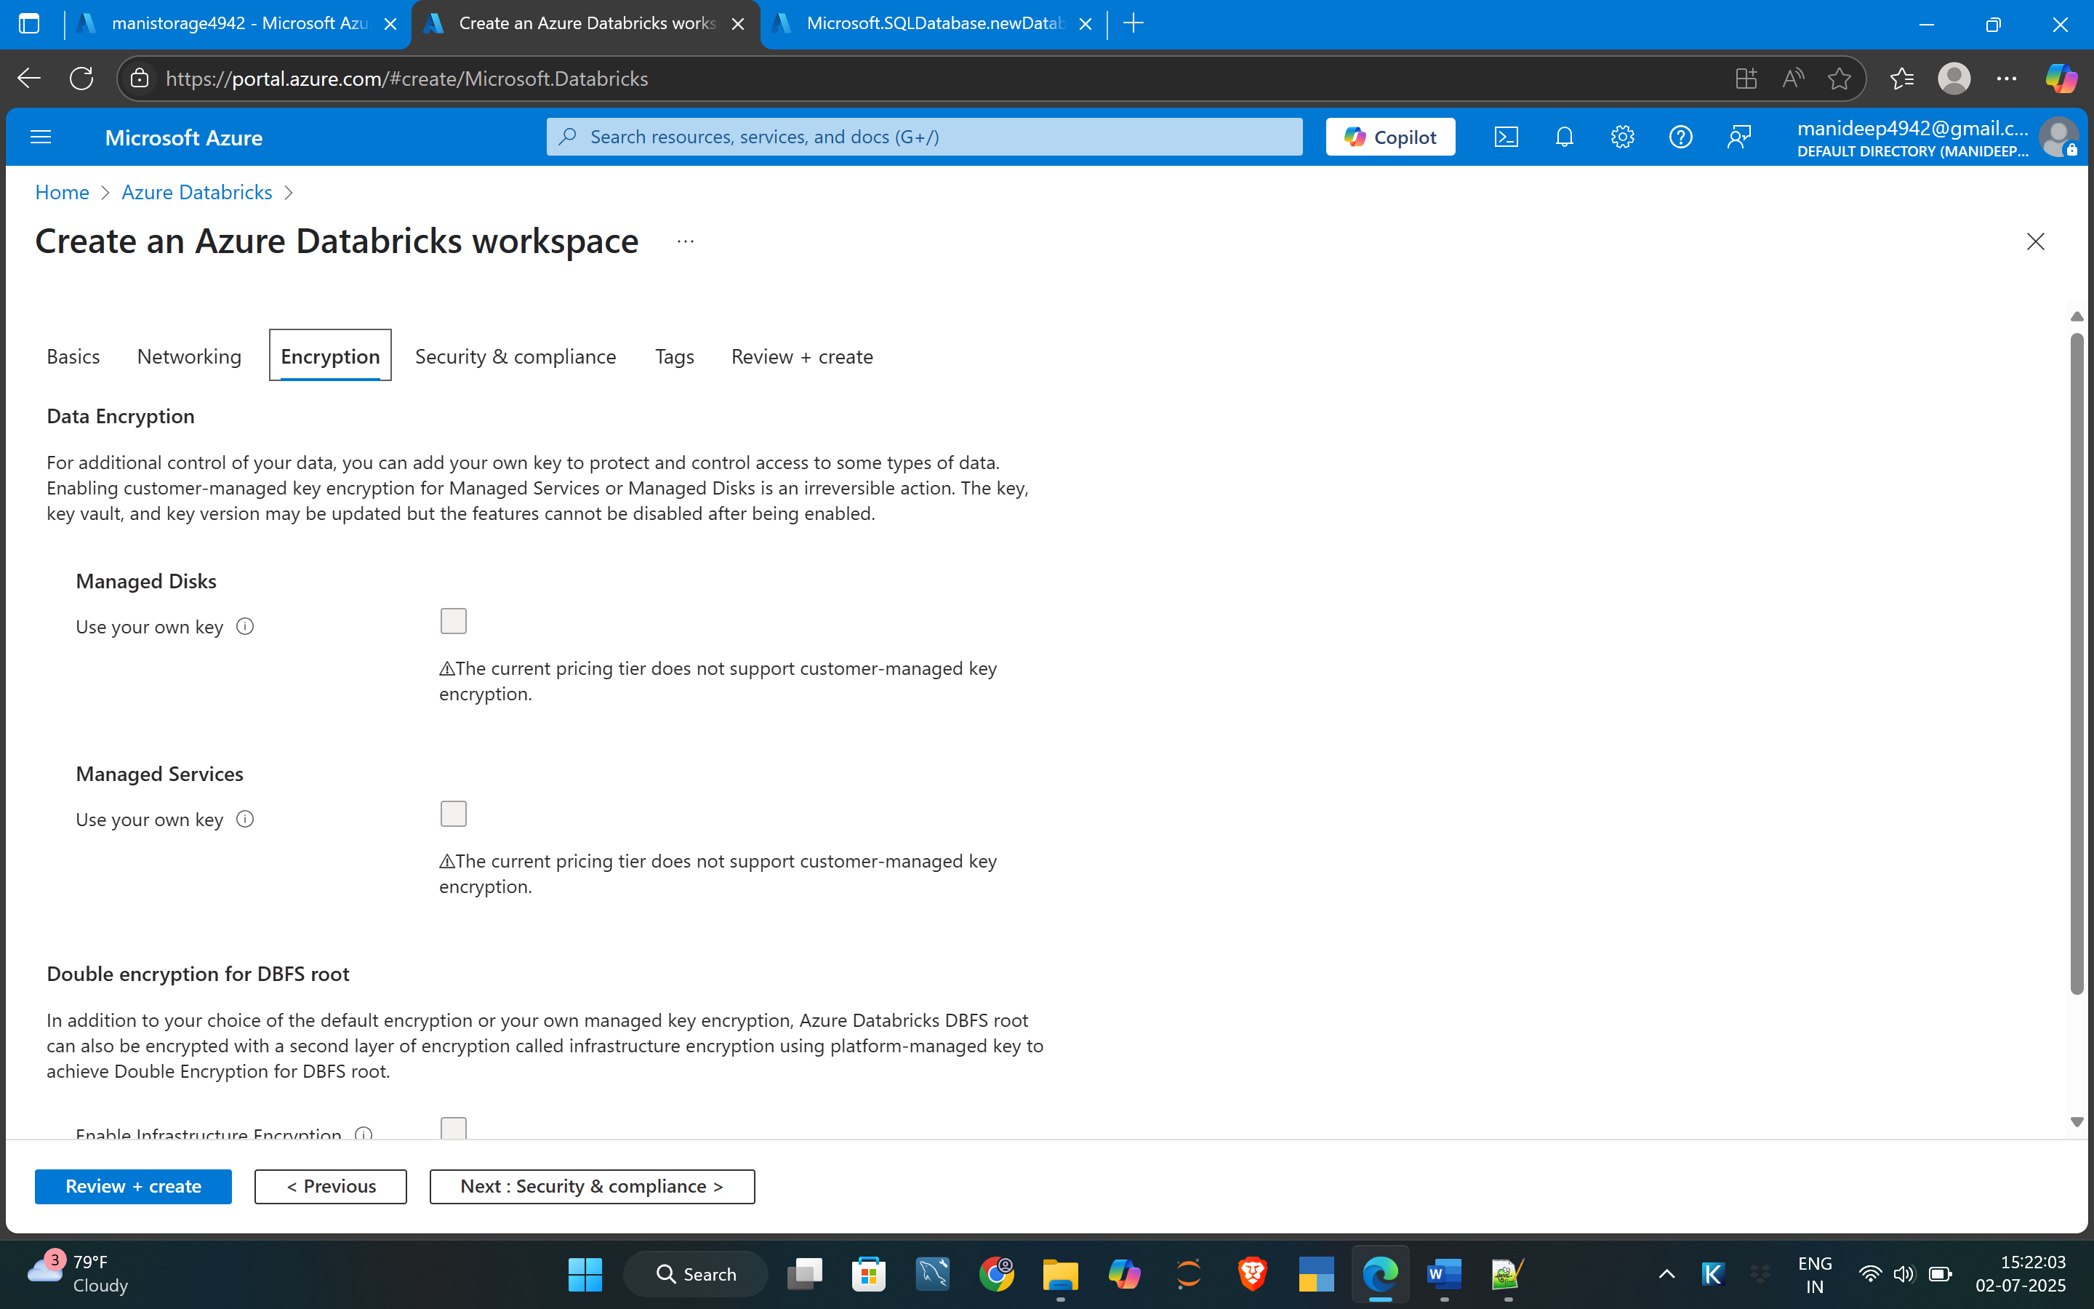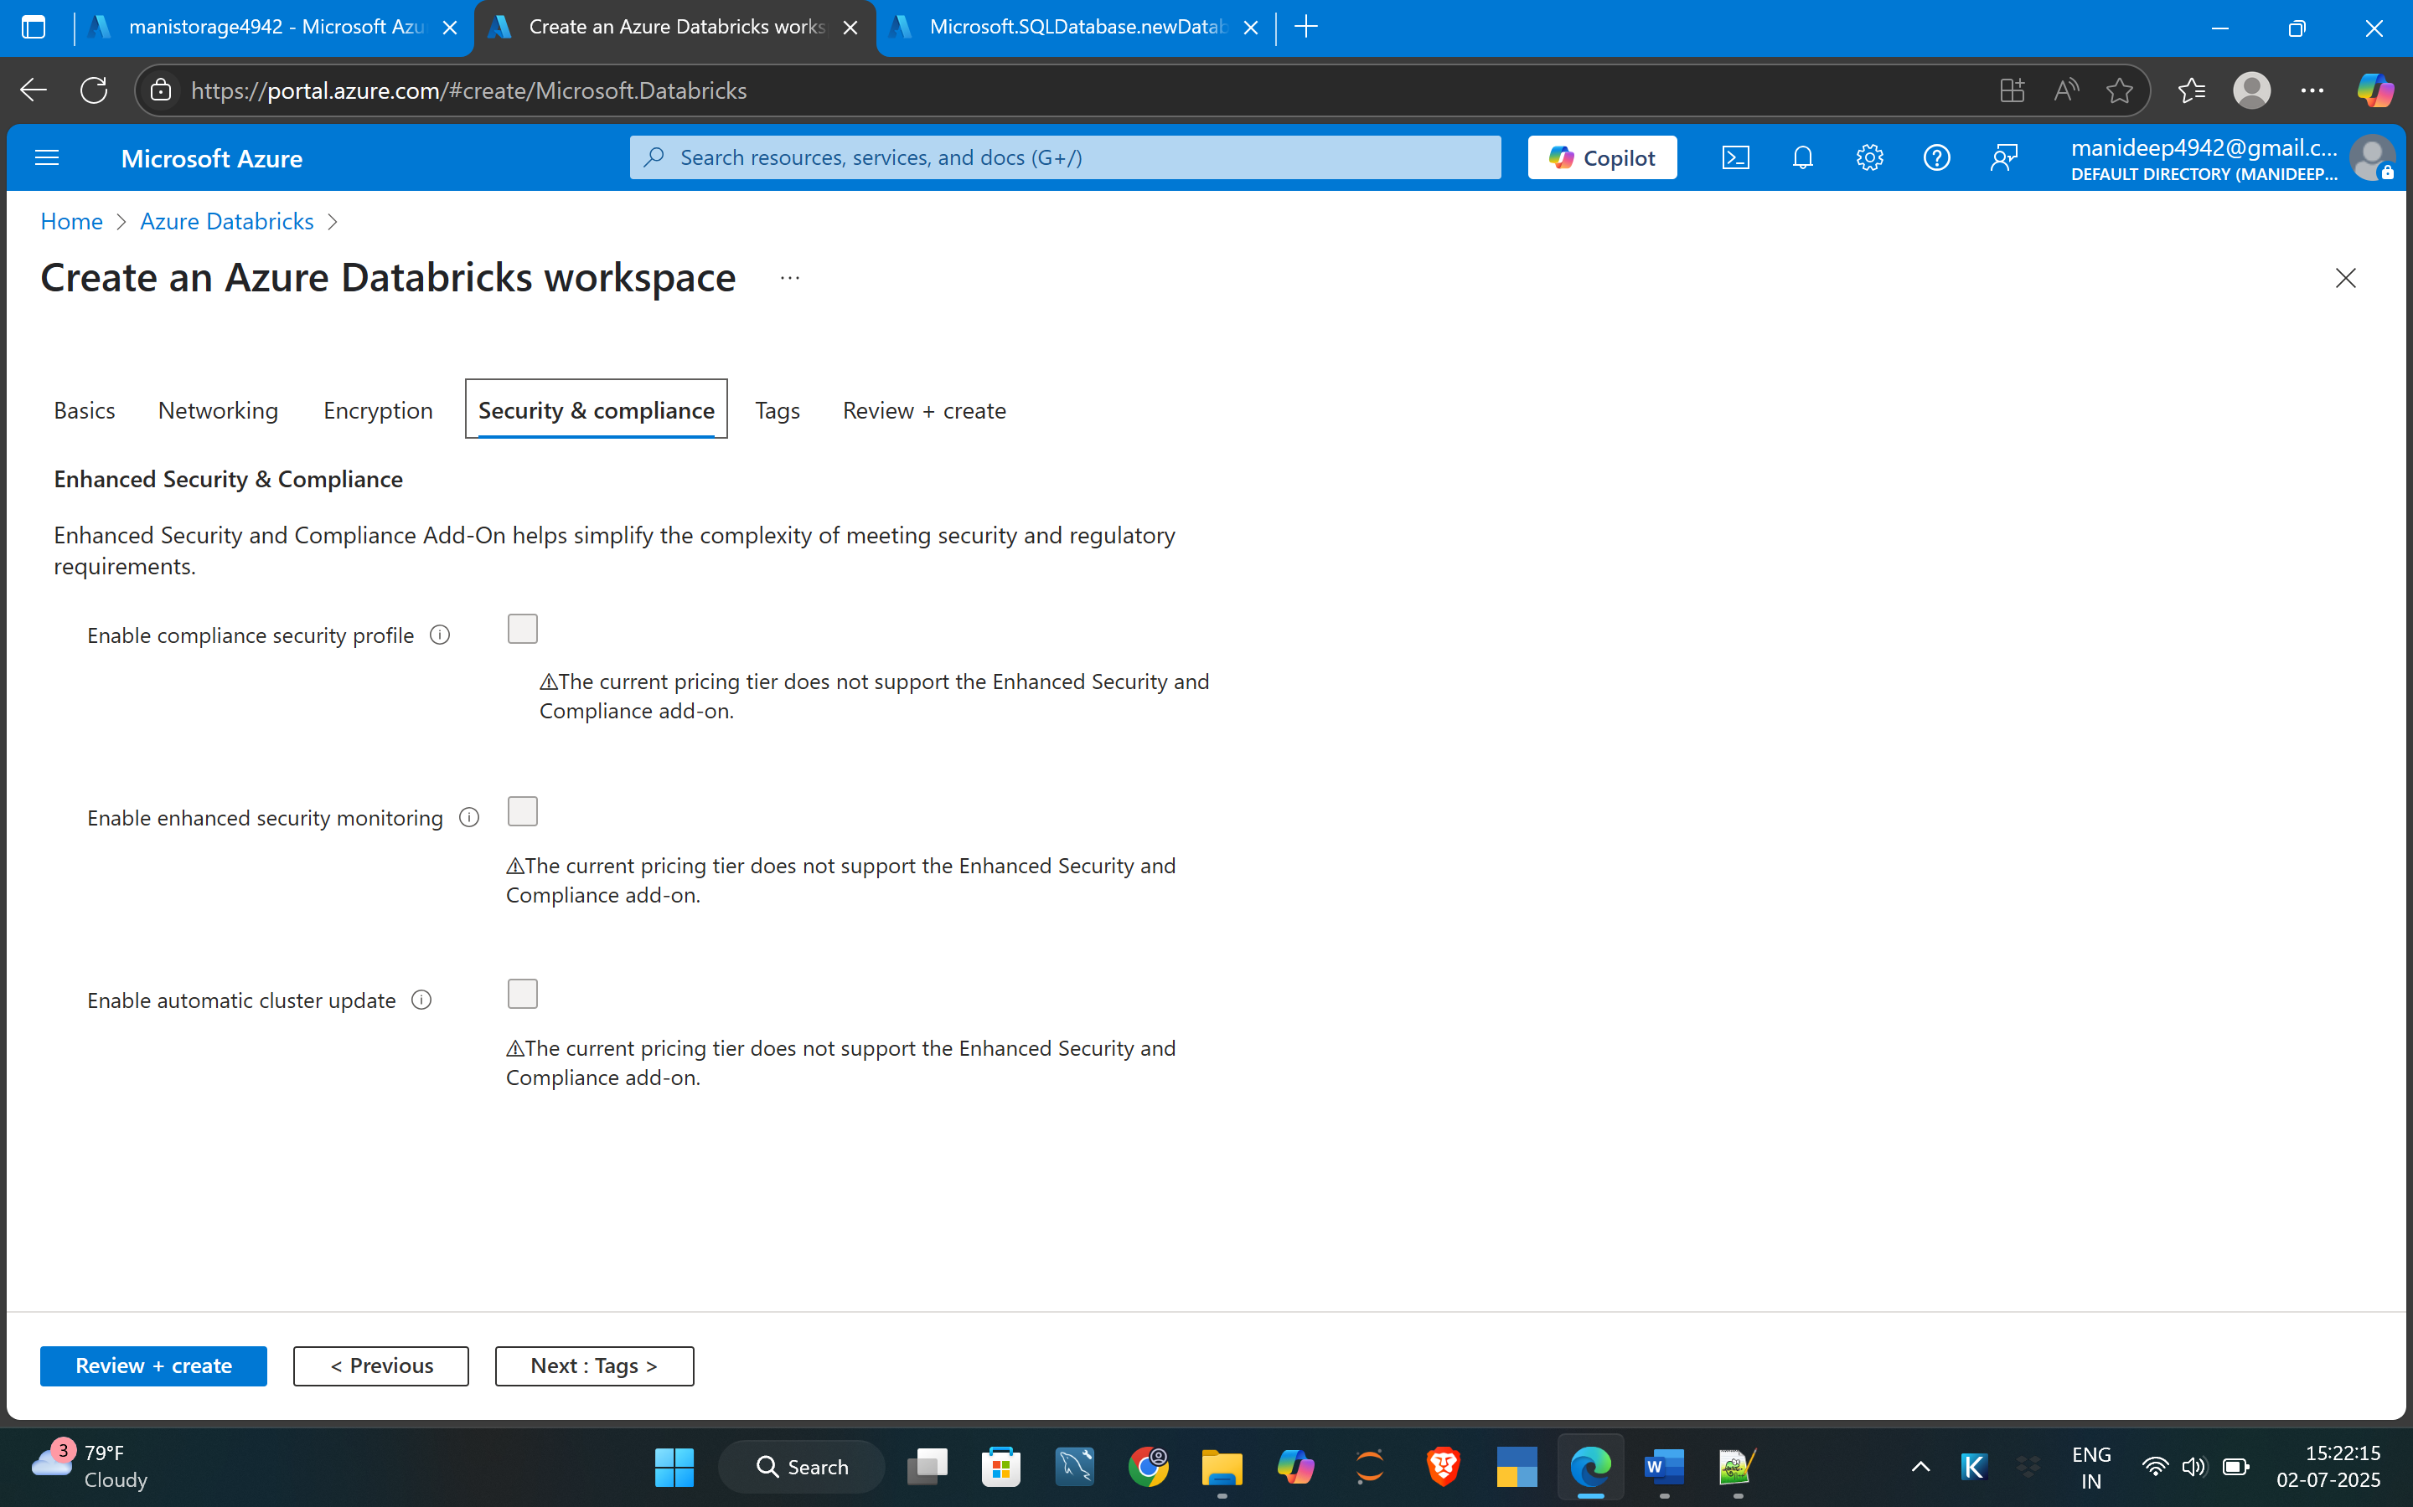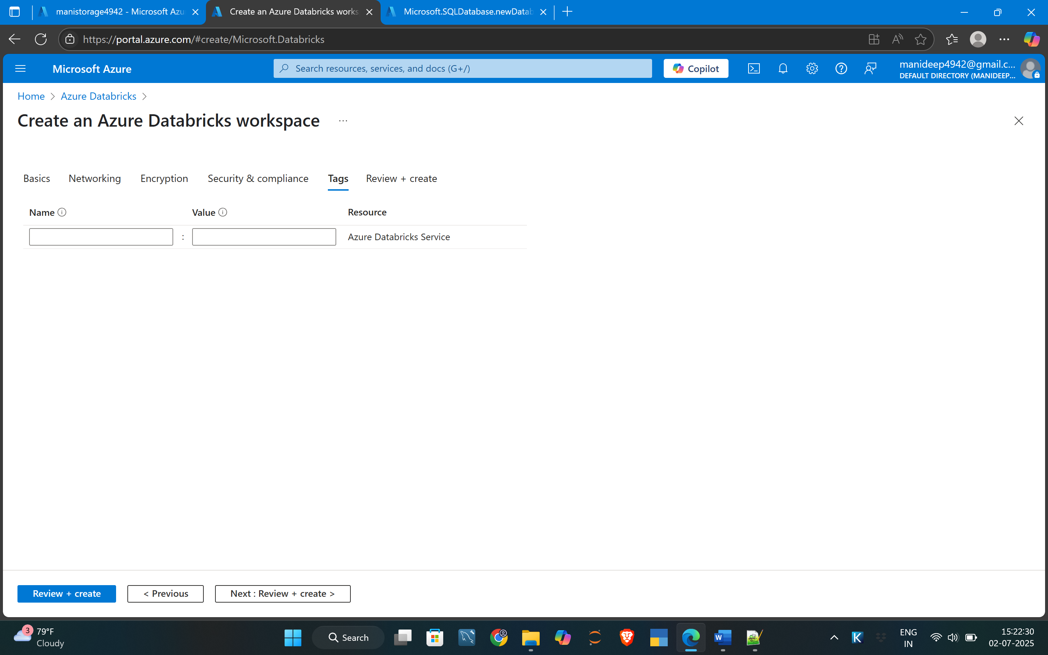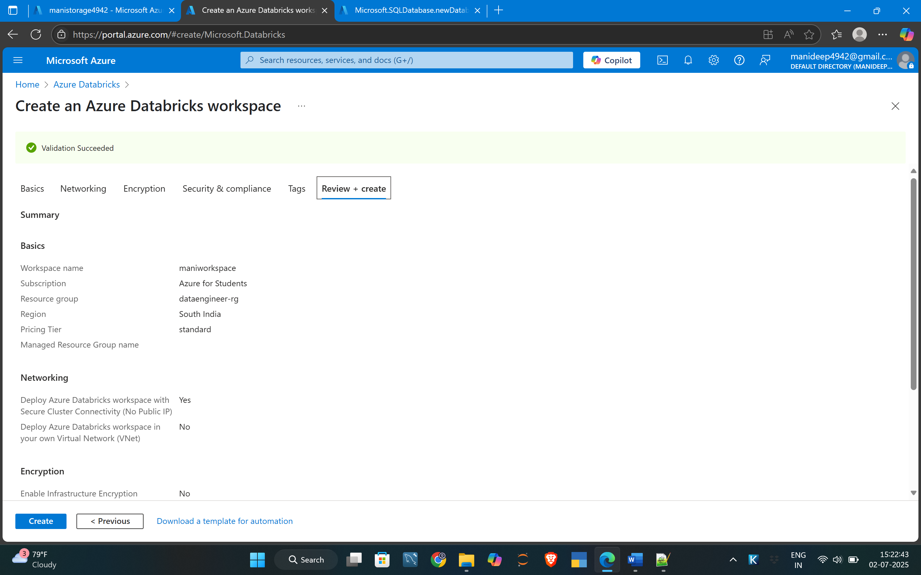

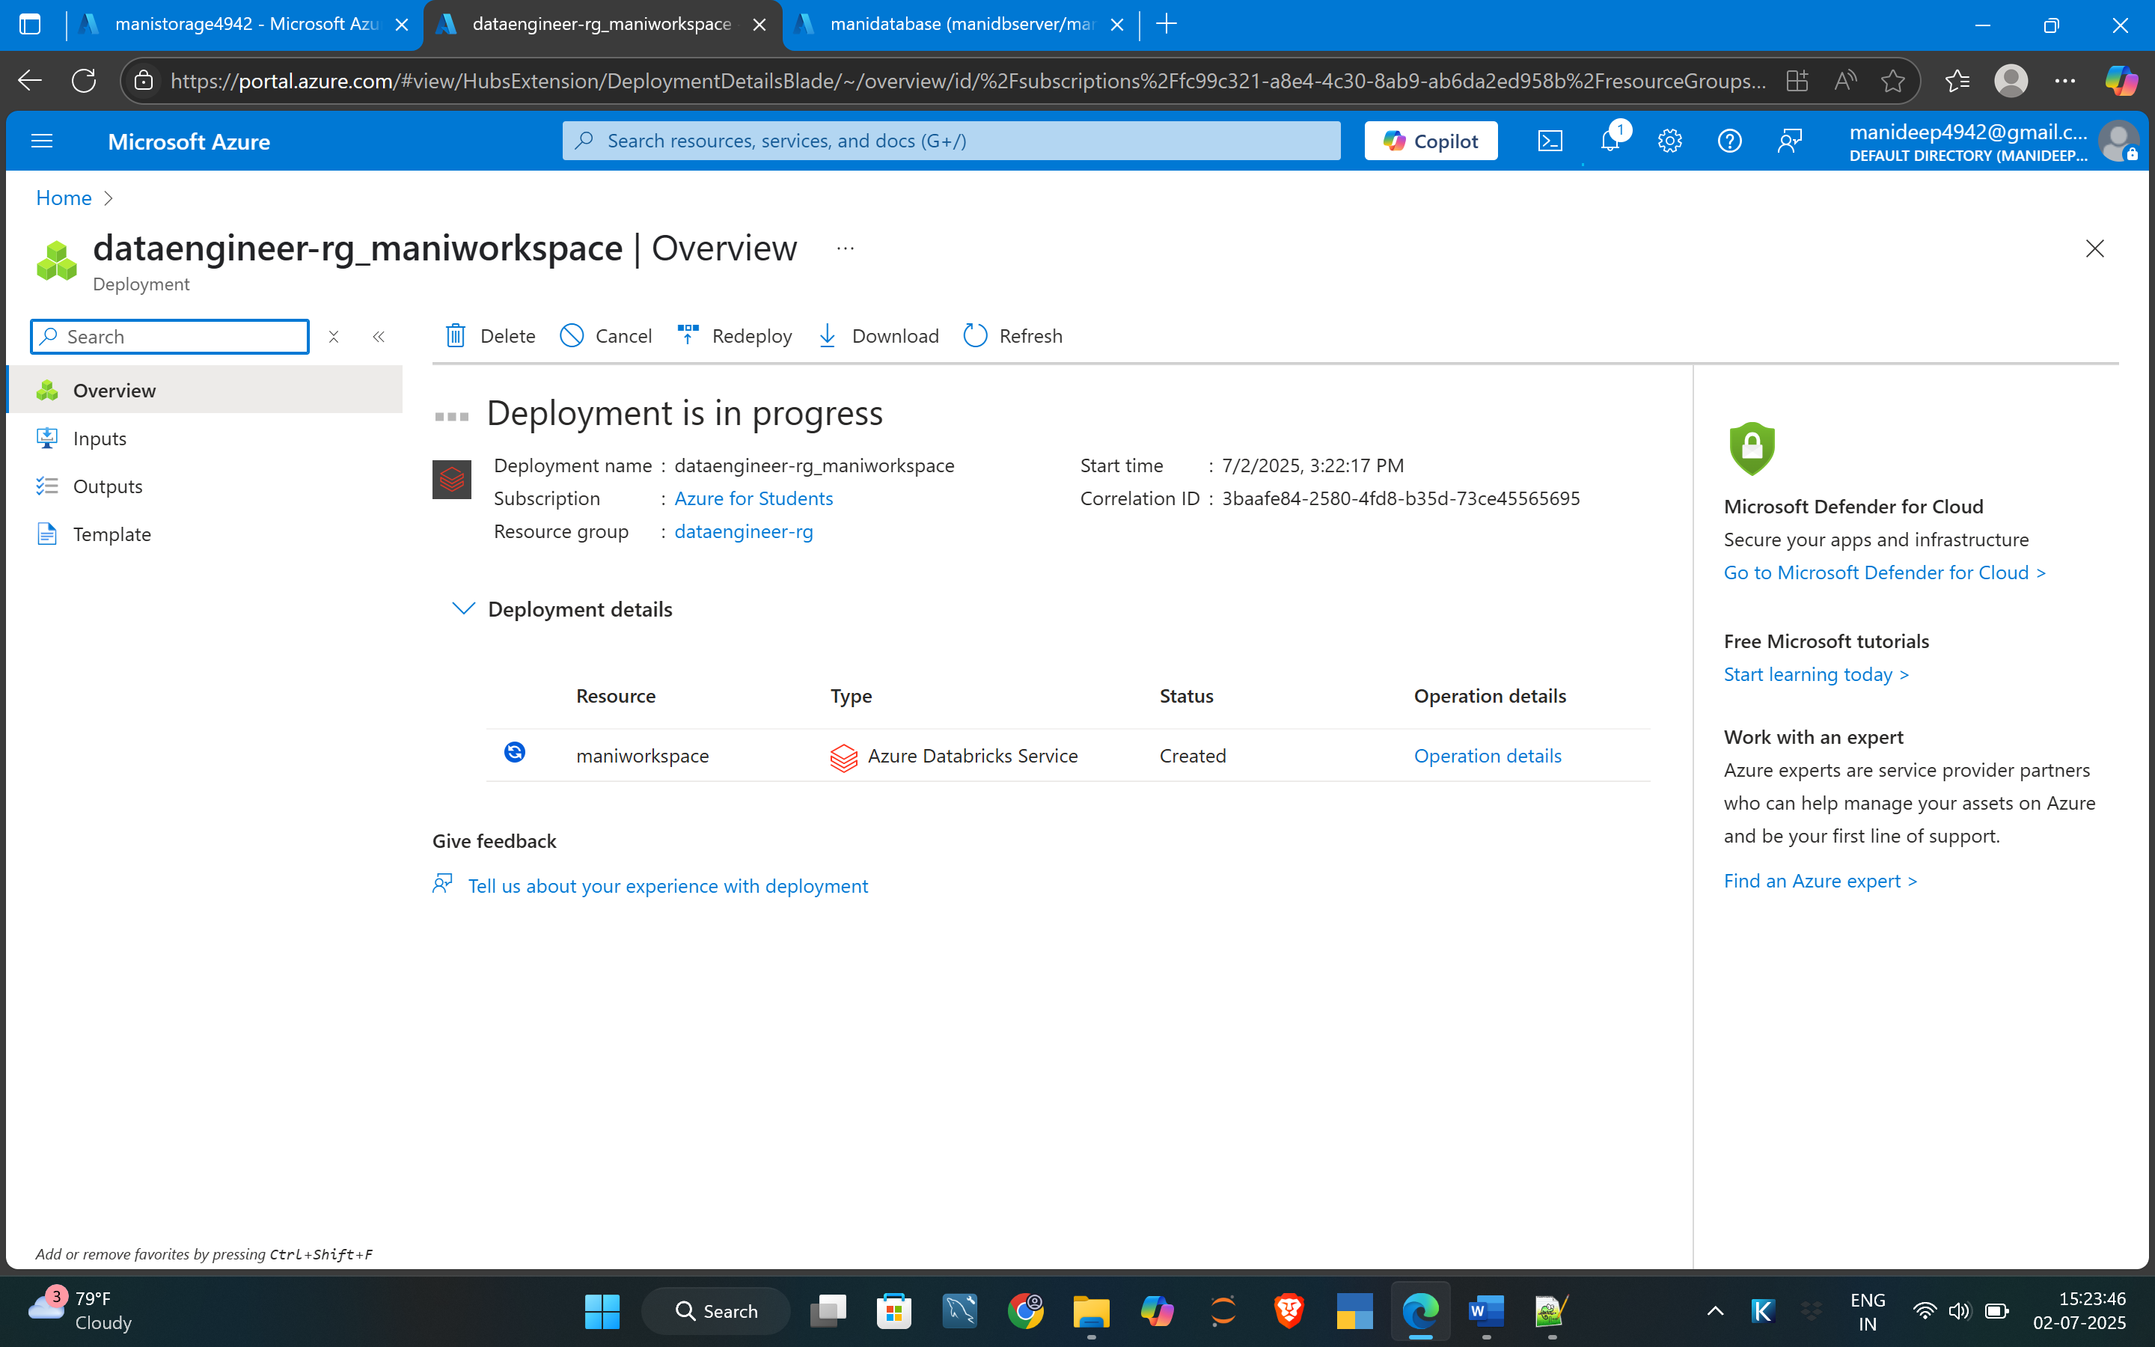

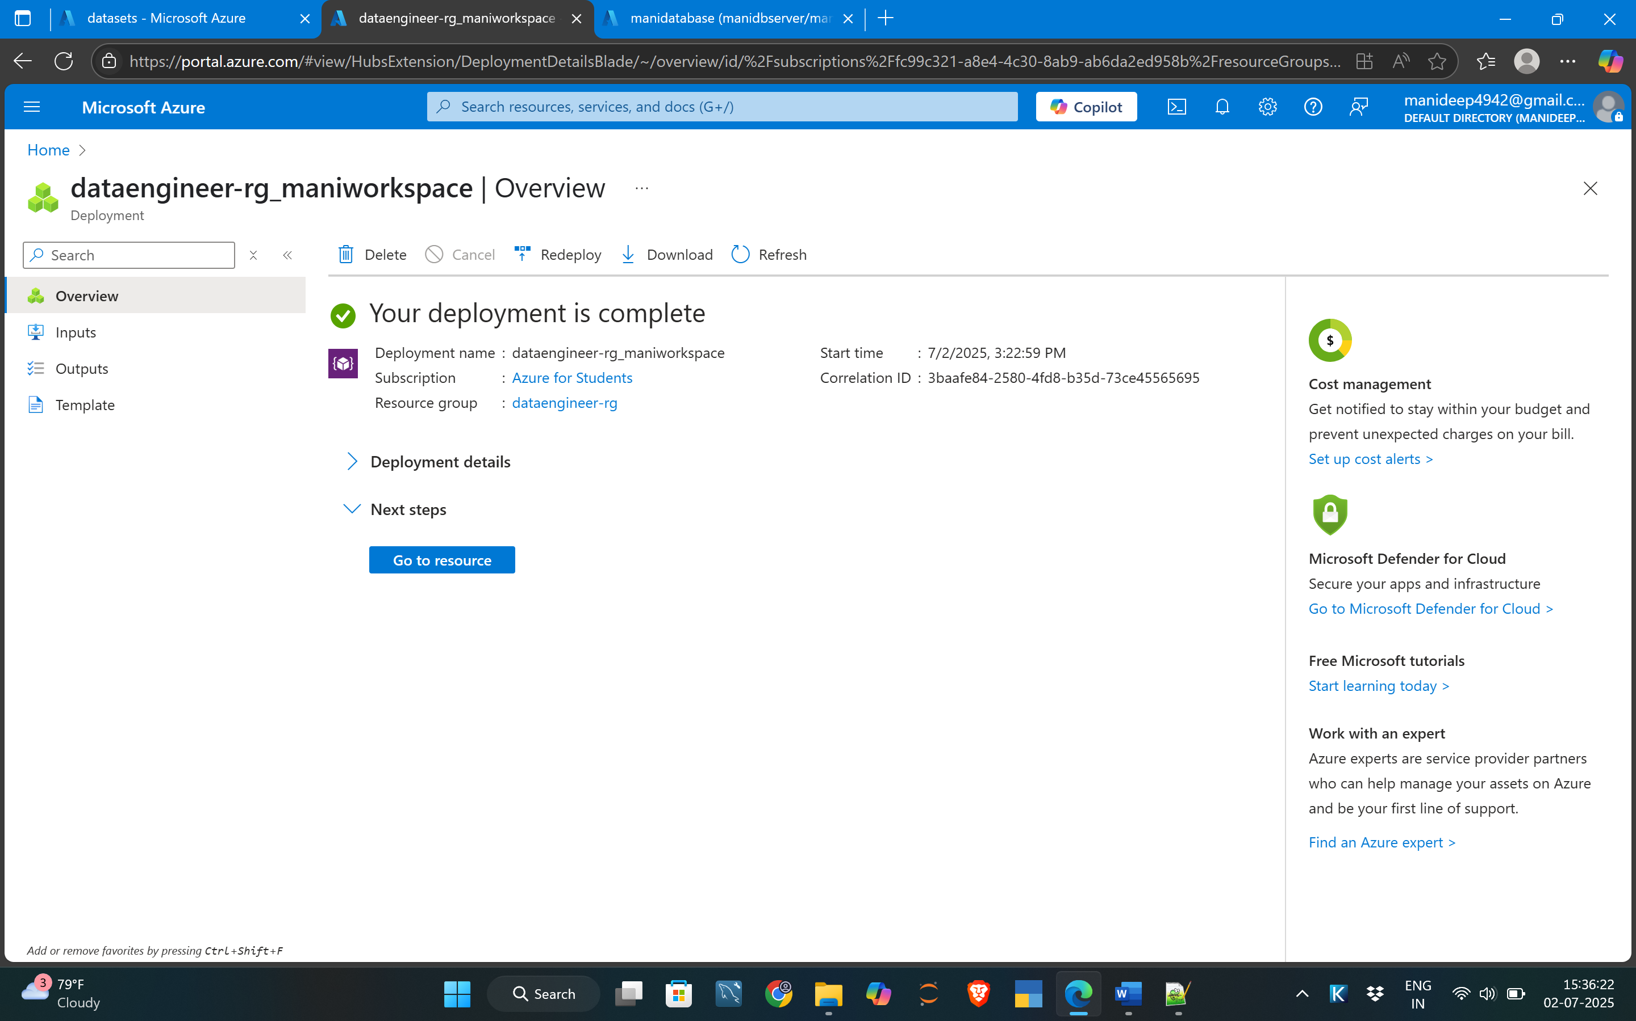

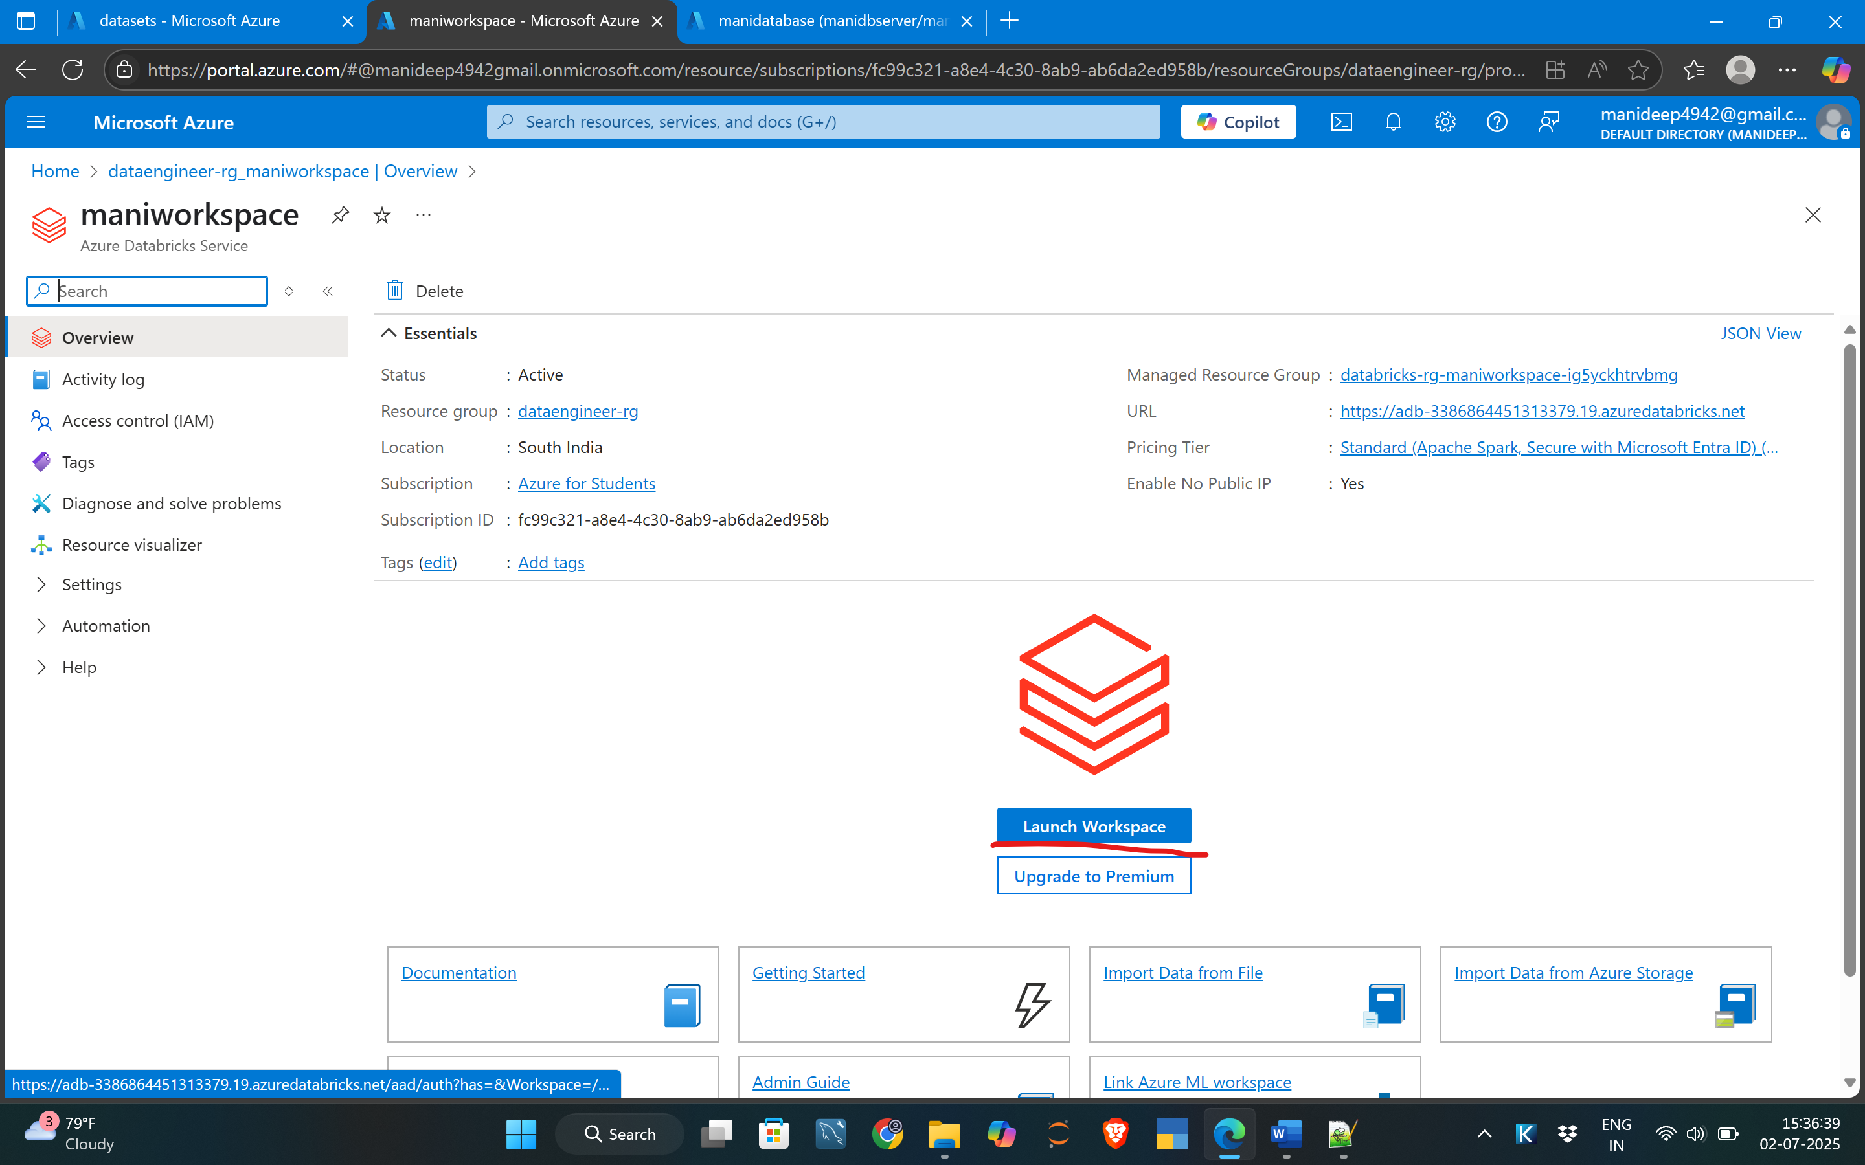

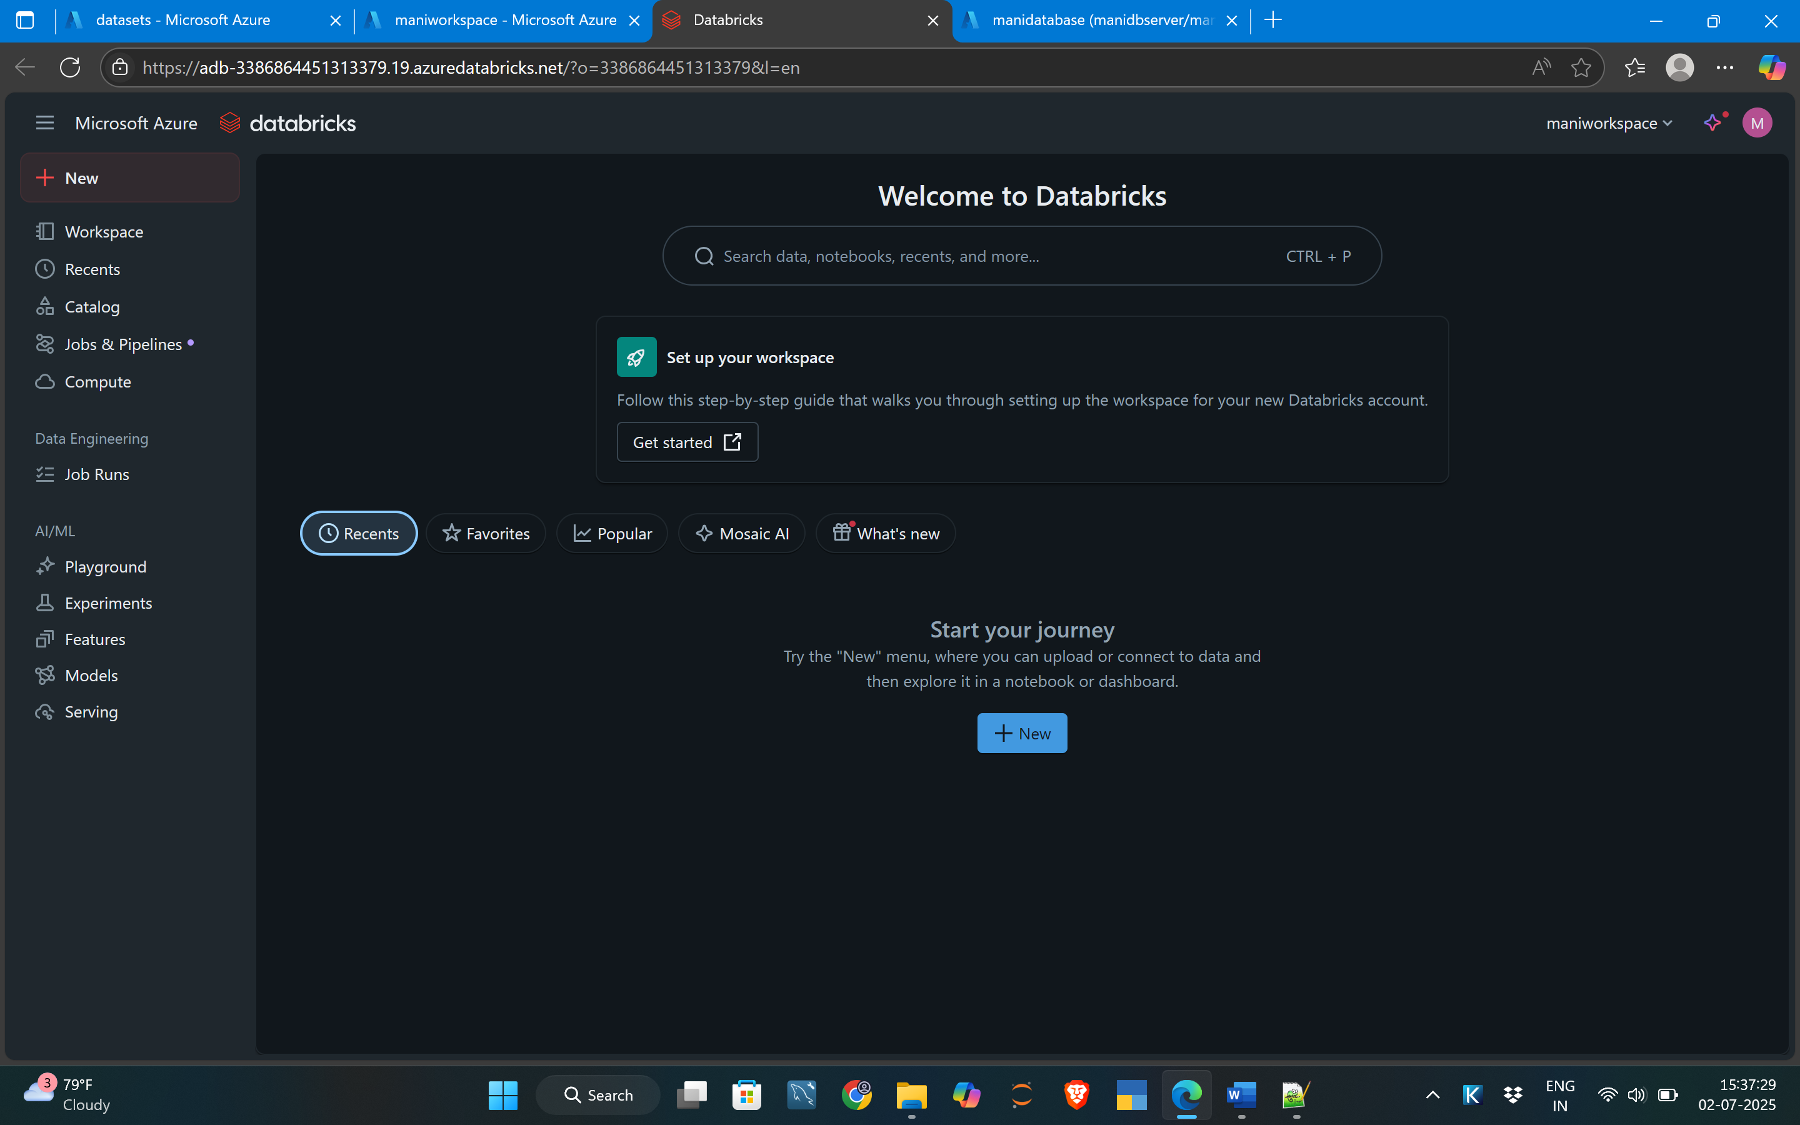

This is what the work space

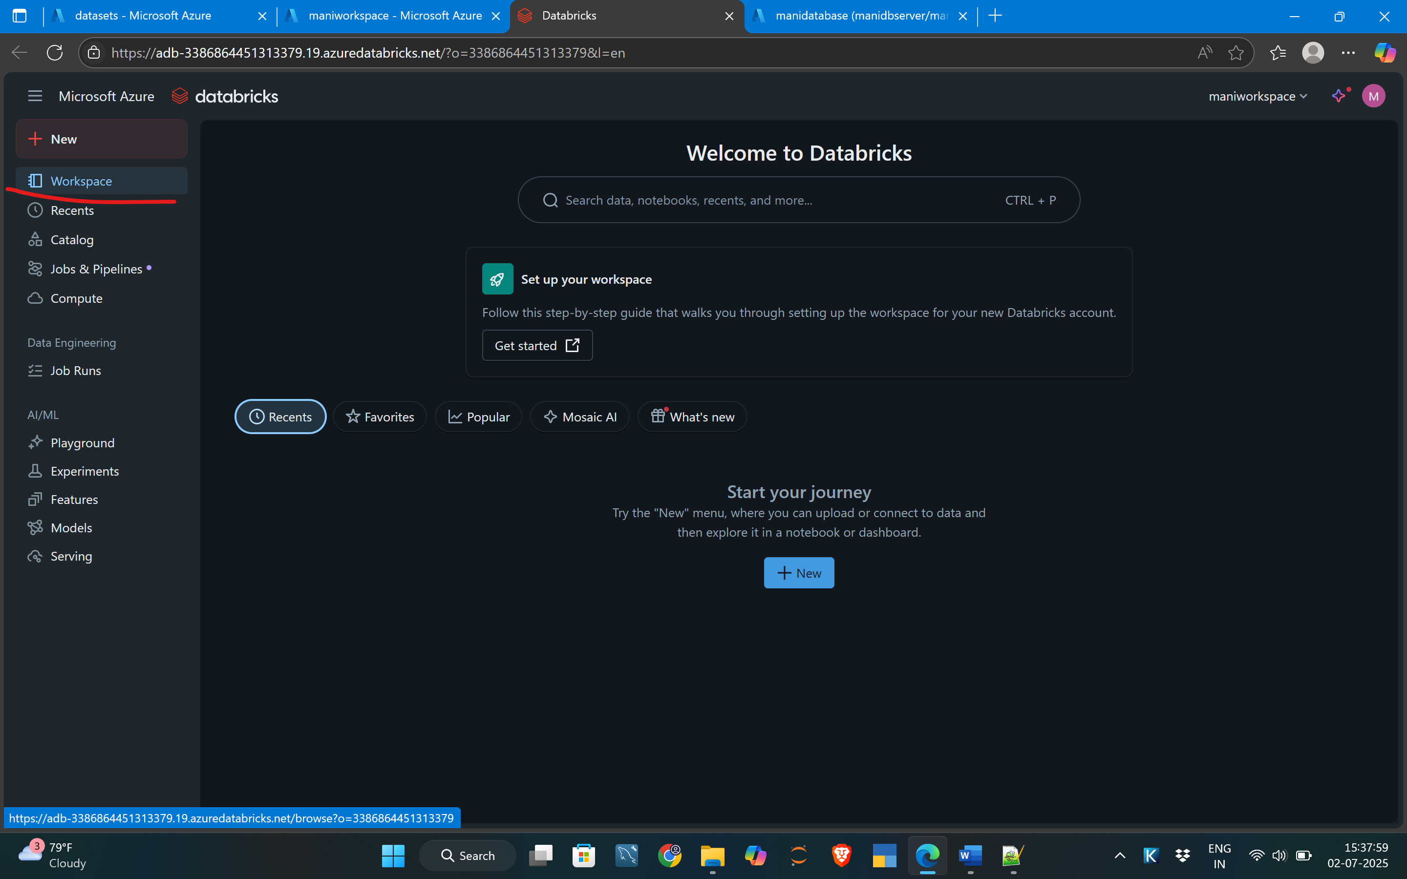

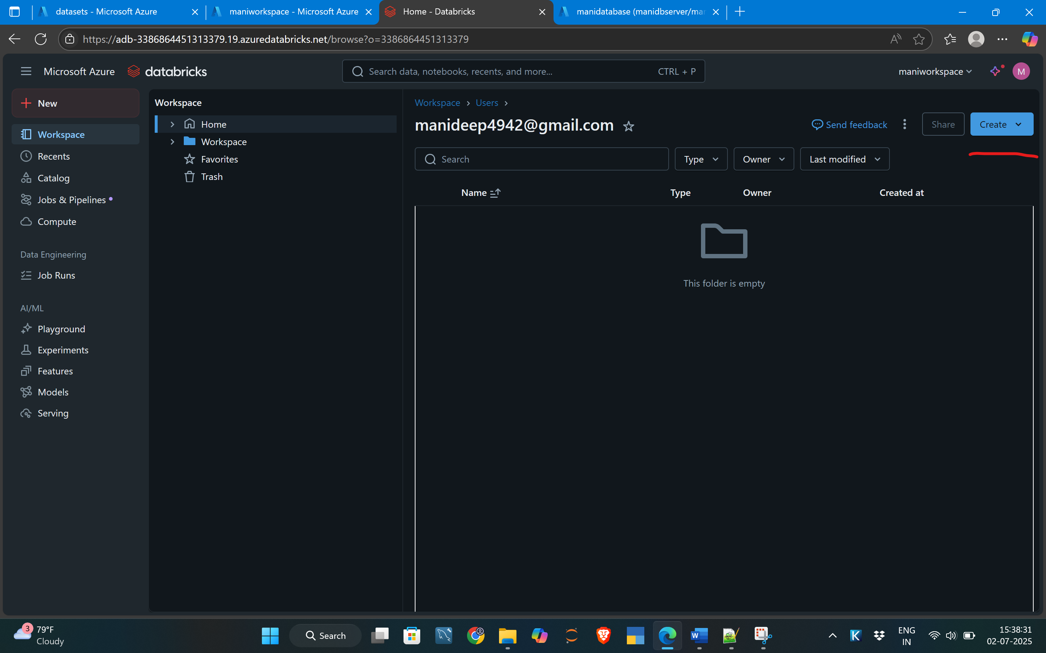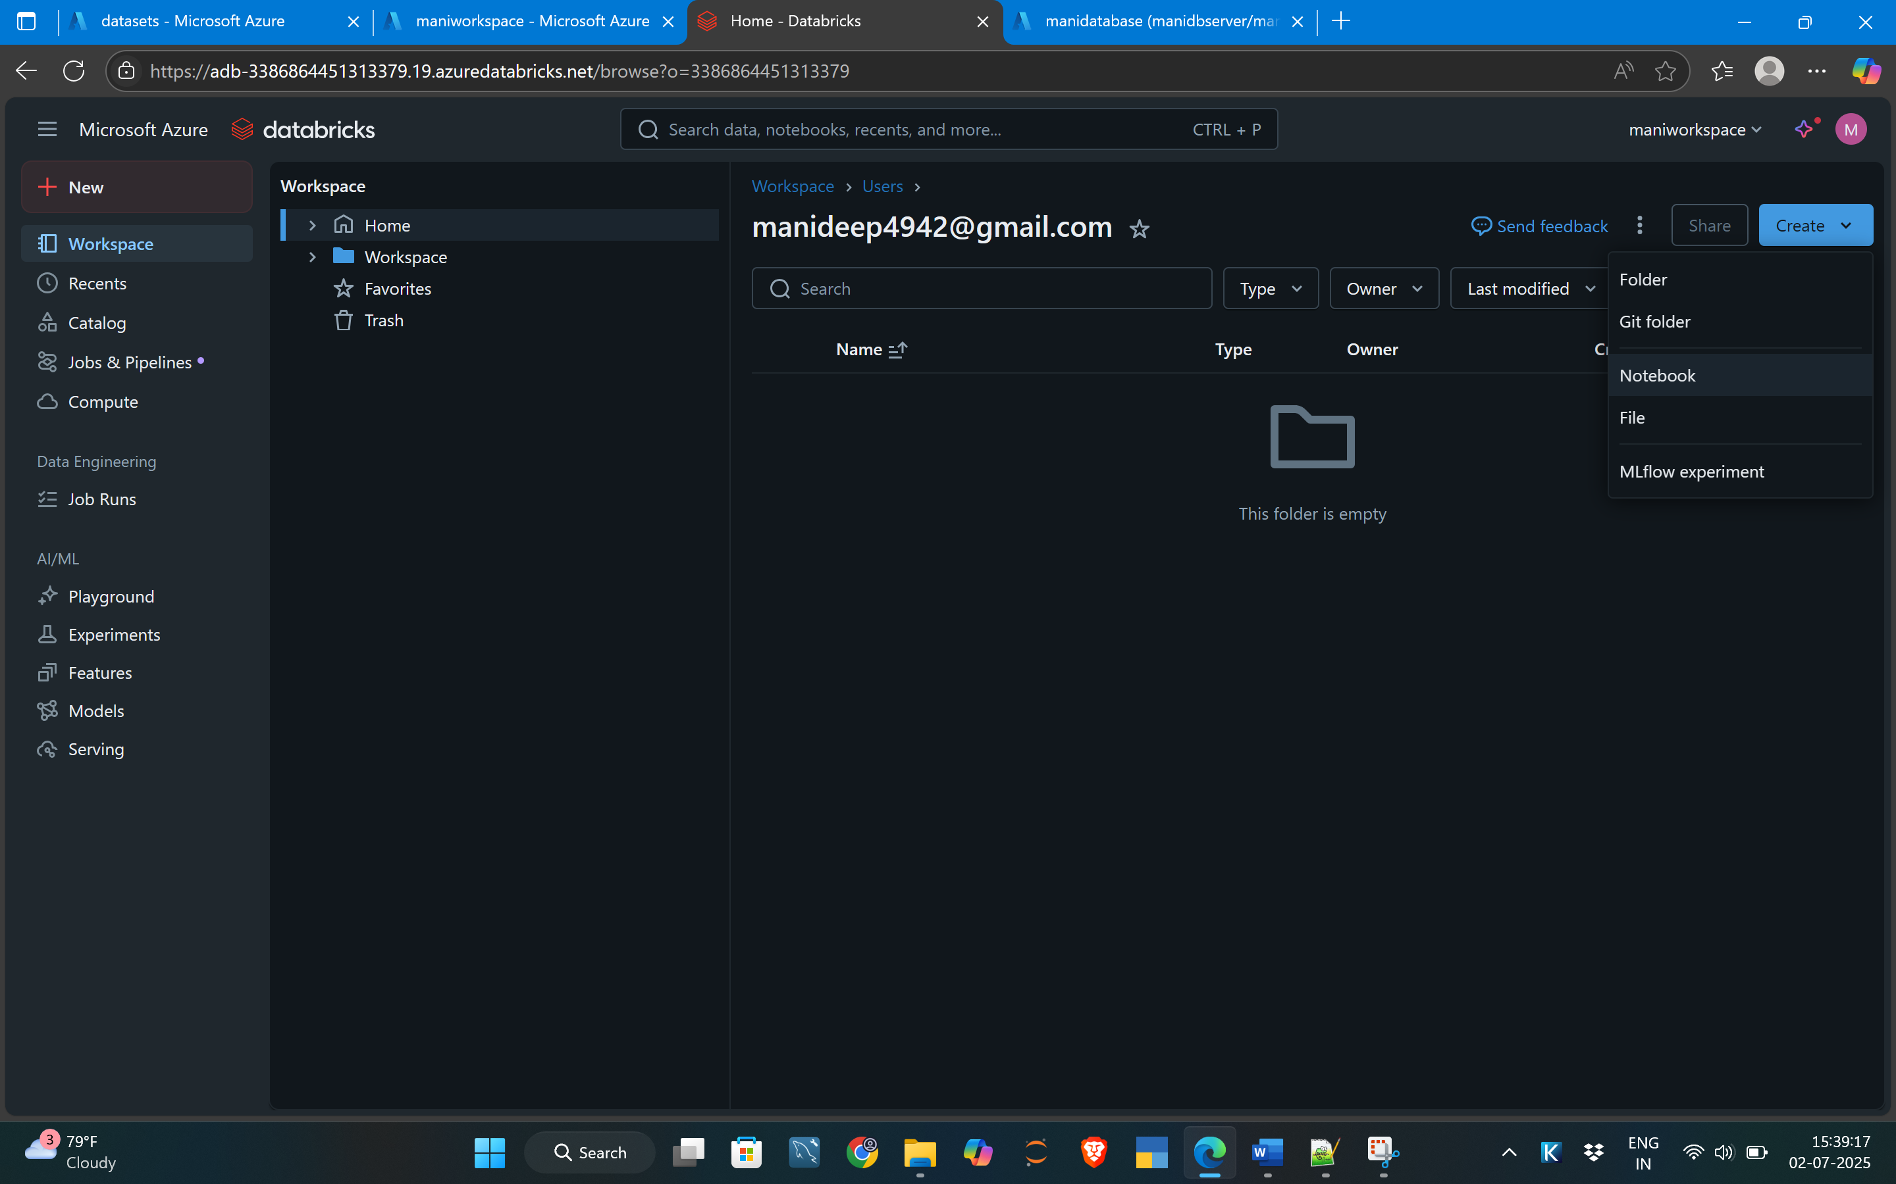

We need to create a compute to run the quarys

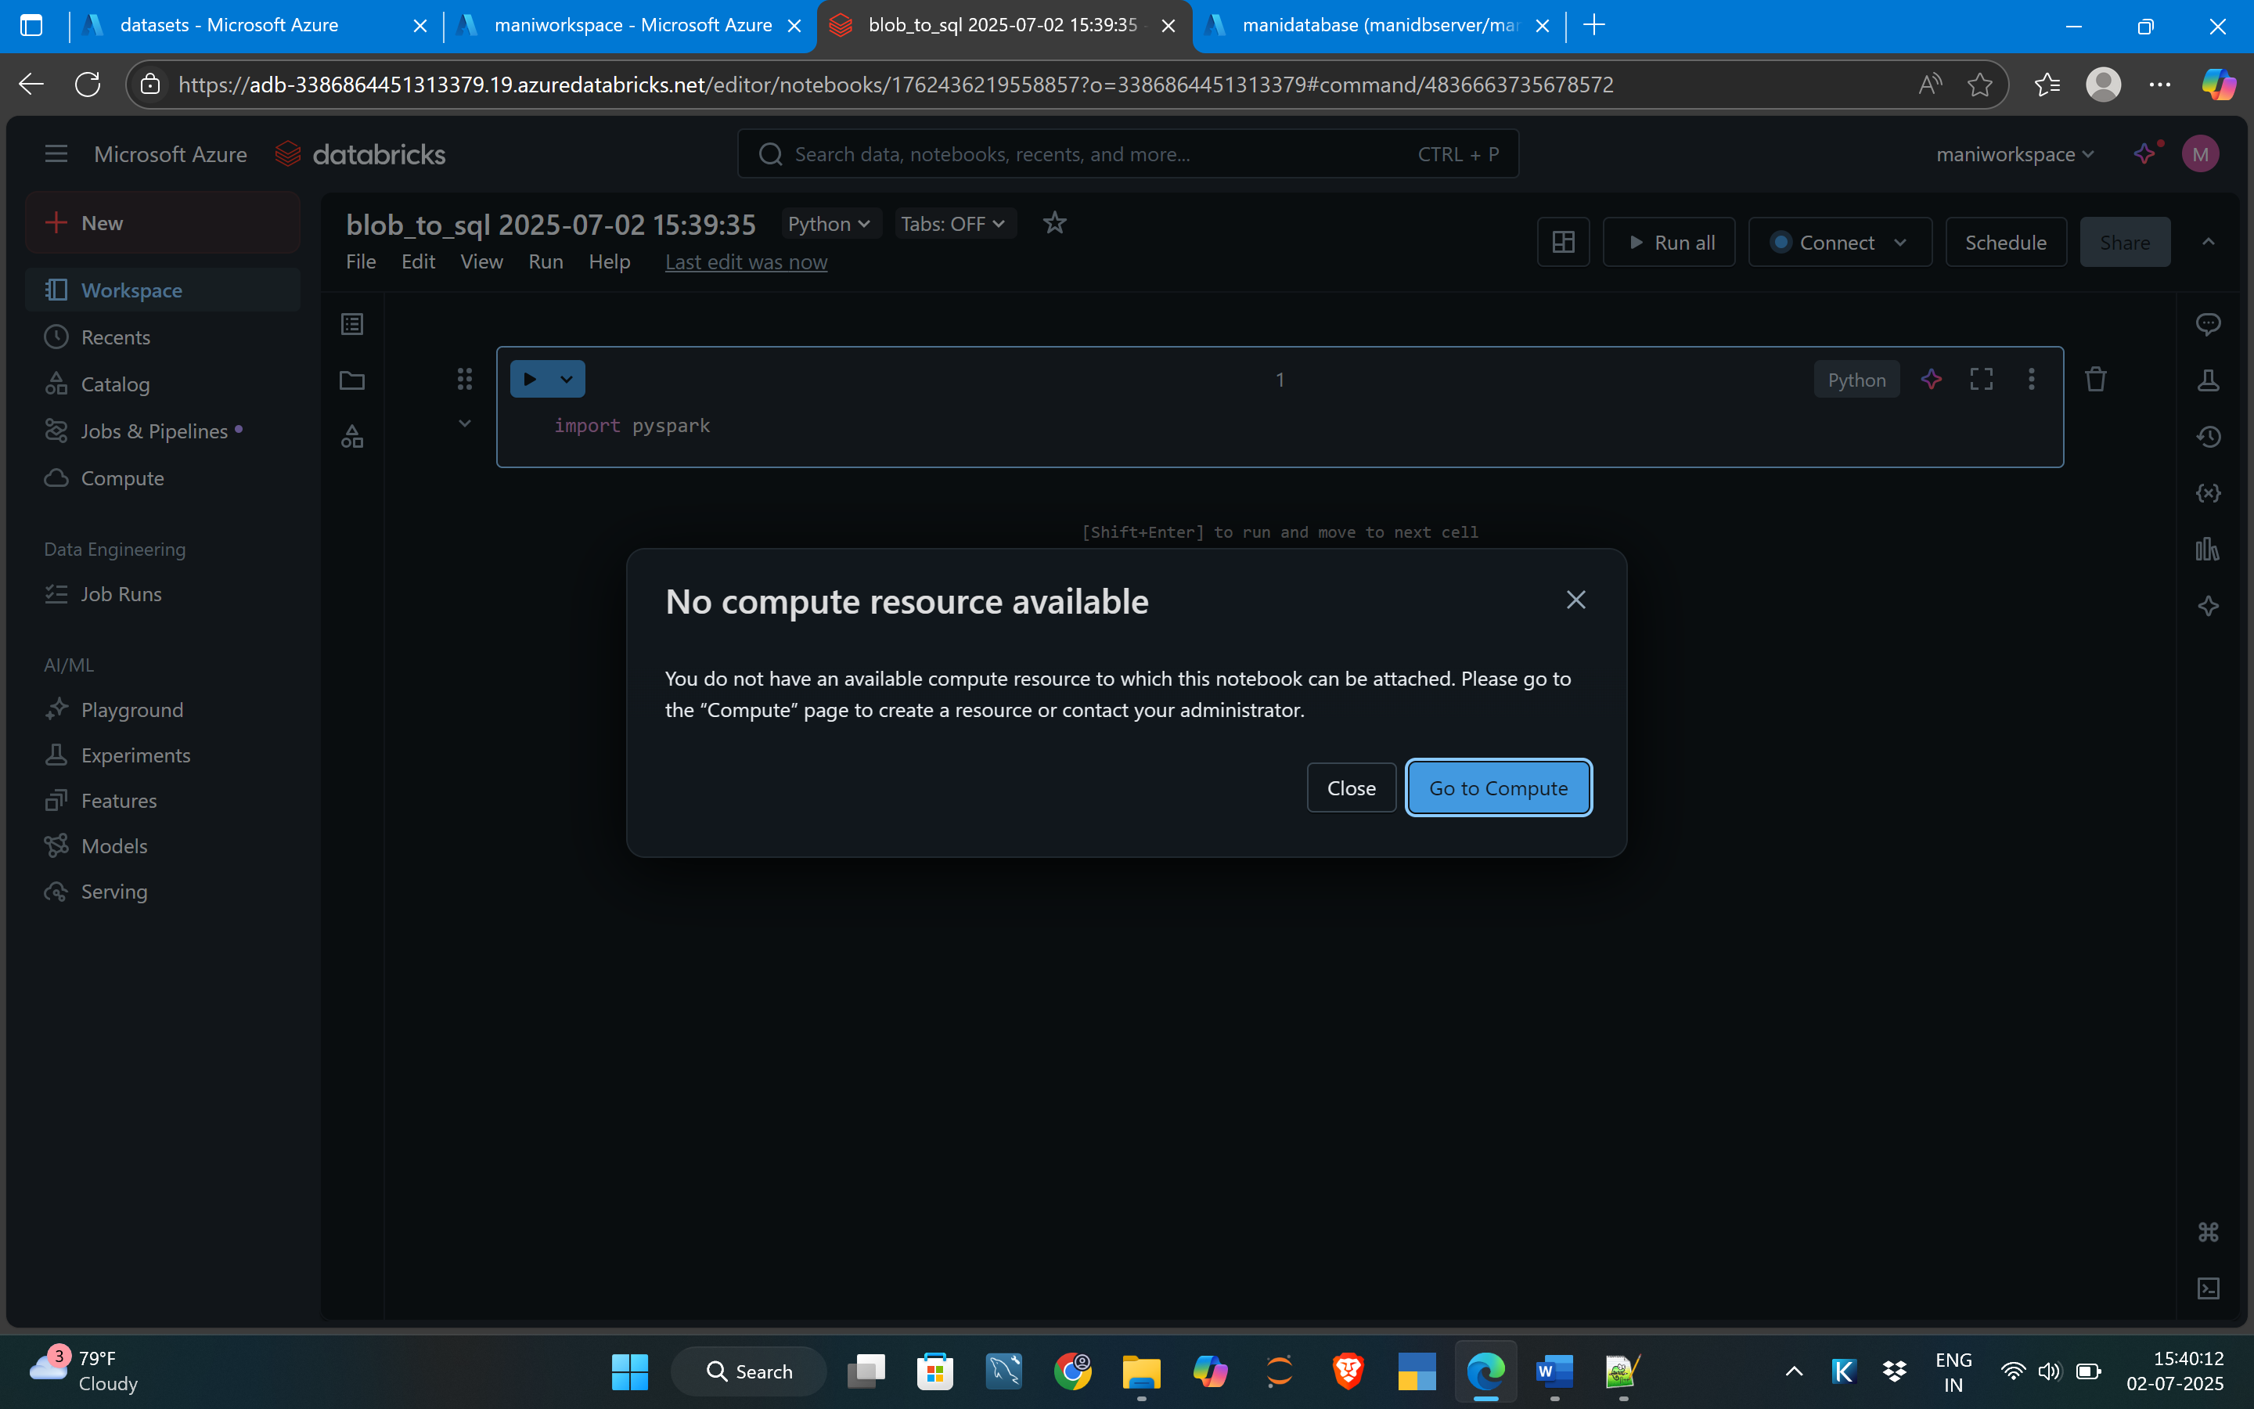

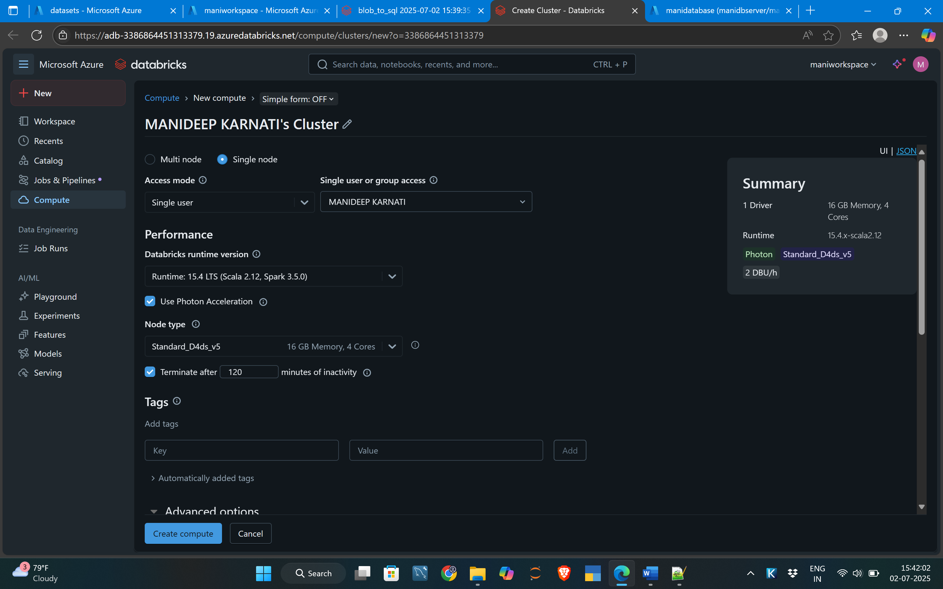

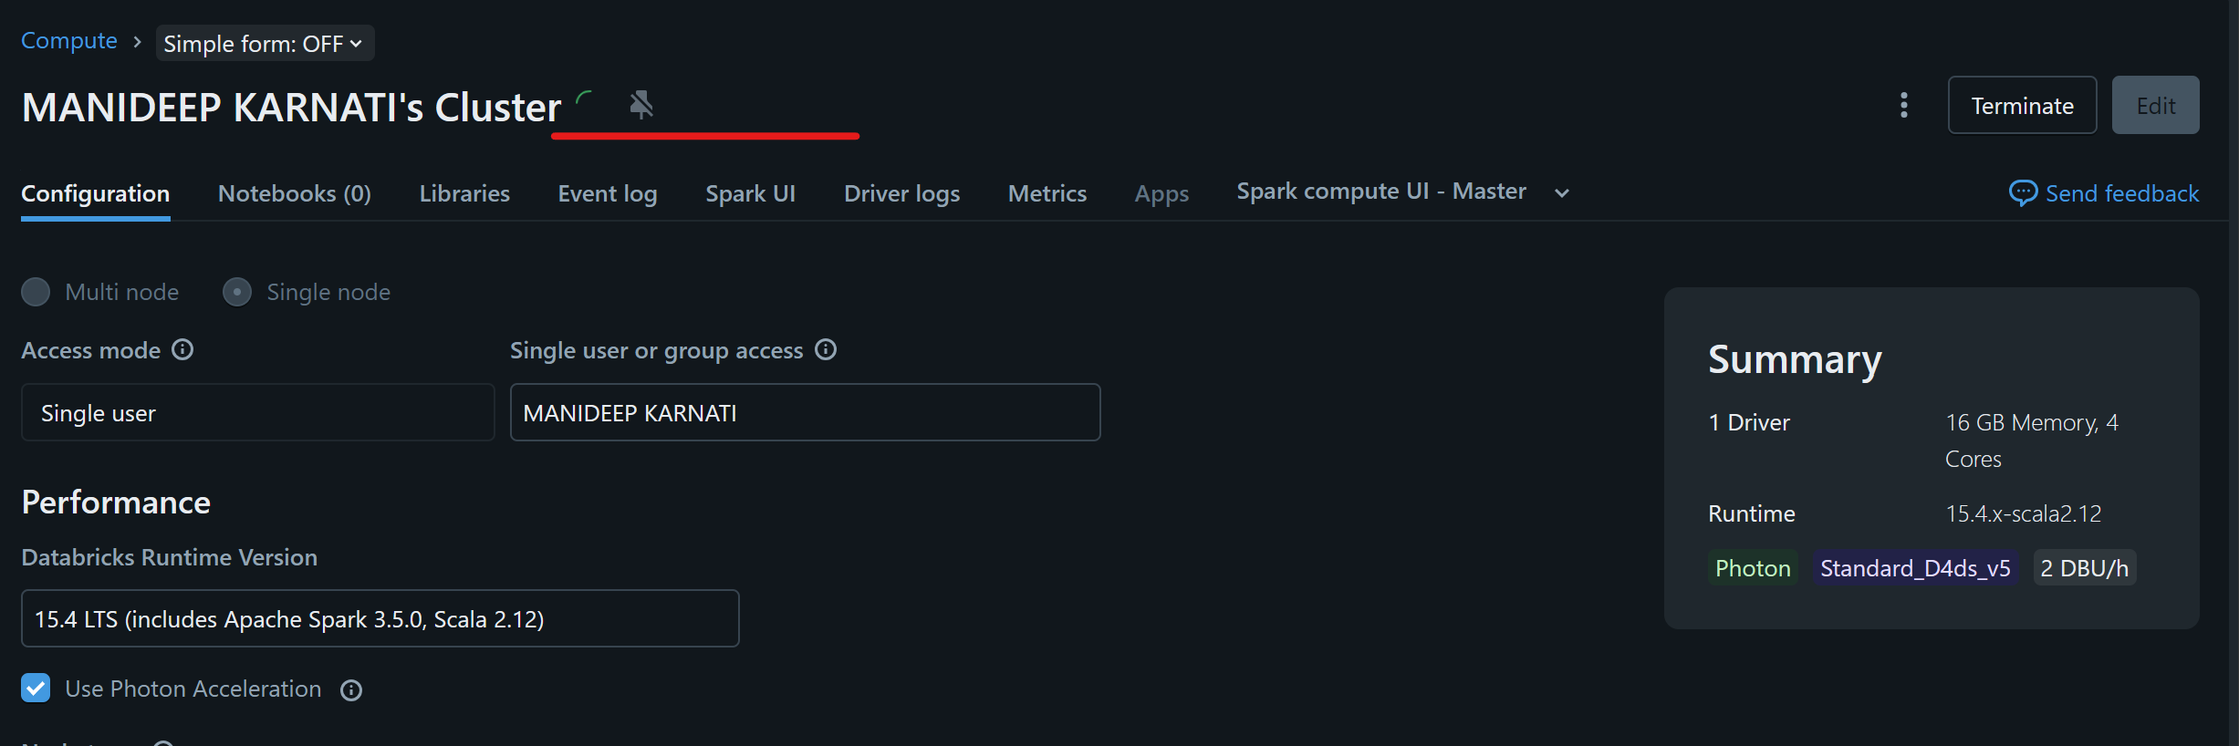

After created computing we need to do some transformation using databricks and push to the sql server databse

After creating the cluste for spark we need to connect blob storage using this line of code.

**spark.conf.set("fs.azure.account.key.<storagename>.dfs.core.windows.net","<blobstorage acceskey")**

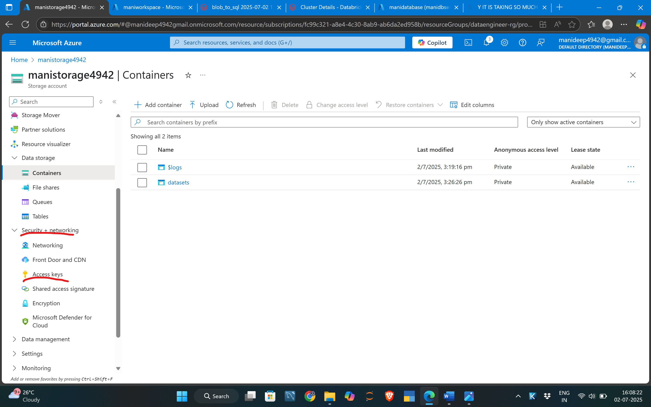

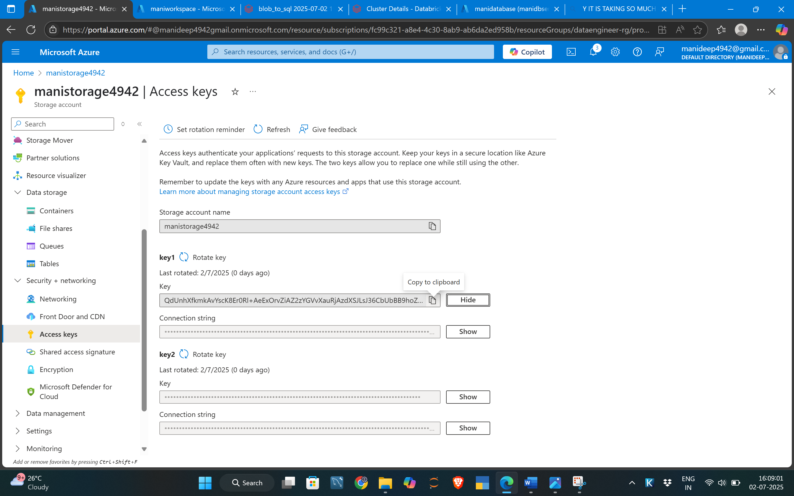

Paster her :

